“Swing It to End It”  is a benefit tournament for  “Jim’s Team to Fight  Alzheimer’s”  Annette Carter, a Vinton business leader, lost her husband of 27 years, Jim, to Alzheimer’s disease. She has become a very strong and powerful advocate and fund-raiser for the Central and Western Virginia Chapter of the Alzheimer’s Association. Annette is consistently one of the top fund-raisers for the Walk to End Alzheimer’s in Roanoke.  Contact Us:  Annette Carter  15786 Stewartsville Rd.  Vinton, VA 24179  Work: 540-890-6899  Mobile: 540-871-0290  Fax: 540-890-2373  cartera98@verizon.net  ... or ...  Rick Crotts  802 Bowman Ave.  Salem, VA 24153  Mobile: 540-580-3116  crottsrick@yahoo.com  Find us on Facebook, Twitter & Instagram under JimsTeam4Alz. |  |  | General Tournament Information  Tournament Check-In begins at 7:00 a.m. for morning; 12:00 noon for afternoon.  All players receive a Zero Friction Golf Glove and a 2-ball sleeve of Titleist Golf Balls.  50/50 Drawing  Tickets for Green Tees, Mulligans, #9 Score Circle, and a Special Long Drive Contest will be available. A discounted Super Ticket will be sold covering all four tickets.  Hole-In-One Contest  Closest to the Pin prizes on Par 3s  Long Drive Contest with Separate Women and Men Divisions  Snacks and Beverages  Lunch Catered By: Country Kitchen  THE ENTRY FORM MUST BE COMPLETED BY THE TEAM LEADER.  PLEASE PROVIDE ALL INFORMATION REQUESTED FOR EACH TEAM MEMBER  PAYMENT OPTIONS:  MAKE CHECKS TO: “SWING IT TO END IT”  CREDIT CARDS ACCEPTED BY PHONE  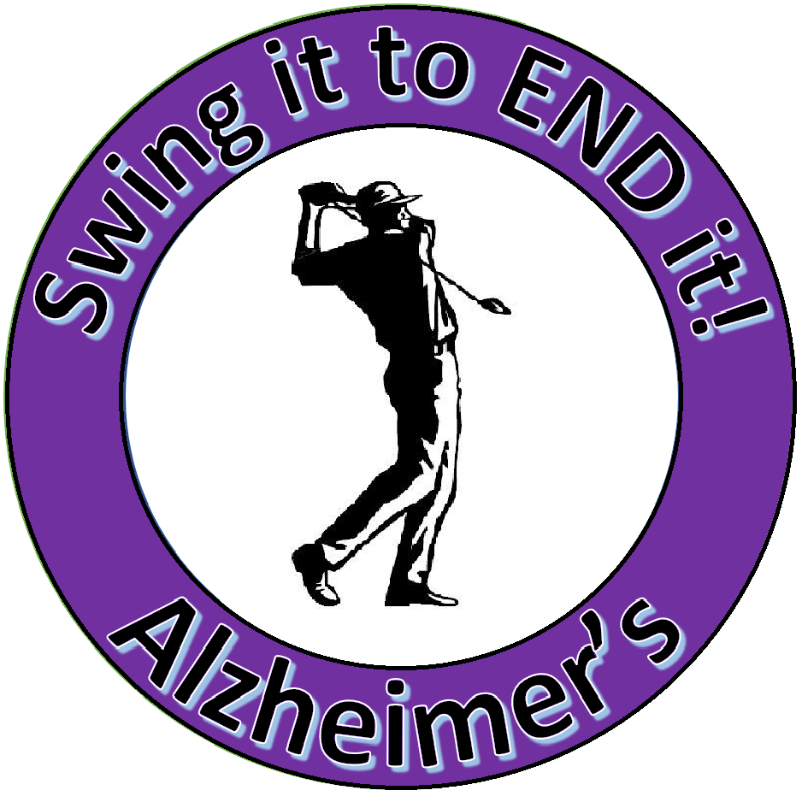 |  |  |  | Sixth Annual  “Swing It to End It”  for Alzheimer’s  Captains Choice Golf Tournament  SUNDAY, August 18, 2019  8:00a.m. & 1:30p.m. Shotgun  Choose your preferred tee time.  HANGING ROCK GOLF CLUB  1500 Red Lane,  Salem, Virginia 24153  540-389-7275  ~ ~ ~  18 Holes of Golf with Cart &  Awards Reception after the tournament
Tournament  Awards & Prizes  1st, 2nd, 3rd, 4th Place Prizes.  Even Last Place wins a Prize.  Each winning team will get a choice of green fees to a great selection of golf courses in the regional area, plus a sleeve of premium Titleist golf balls per player.  Silent Auction Items:  Signed Items by P. Buckley Moss  Growlers from Local Breweries  Salem Red Sox Box for 1 Game  and many, many more to come  I |  |  |  | Tournament Registration Form:  $70 per person / $280 per Team  Sunday, August 18, 2019  Hanging Rock Golf Club, Salem, VA  Circle preferred time below:  8:00a.m. or 1:30p.m. Shotgun Start  Note: If we don’t have enough teams for the 8:00a.m. tee time the Team Captains will be notified that all teams will tee off at 1:30p.m.  Team Captain: _________________ Phone: ________________________  Address: ______________________ Email: _________________________  Golfer #2: _____________________  Phone: ________________________  Address: ______________________ Email: ________________________  Golfer #3: ____________________  Phone: ________________________  Address: _______________________ Email: _________________________  Golfer #4: _____________________  Phone: ________________________  Address: _______________________ Email: _________________________ |  |  |  | Sponsorship Levels:  $ 100 - Hole Sponsor  $ 200 - Sole Hole Sponsor – Pick Hole  $ 500 - Beverage Sponsorship  $ 1000 - Co-Sponsorship of Tournament  $ 2500 - Tournament sponsorship – will be featured on TOURNAMENT BANNER and on all literature related to the tournament.  A SPECIAL THANKS to  Last Year’s Tournament Sponsor:  Brambleton Imports  and to last year’s  Sole Hole Sponsors:  Brambleton Deli and Martha Moore  Davenport Investments  Domino’s Pizza and Zack Barrett  James Jessie Roofing  Long & Foster – Jeannine Hanson  NAI Commercial Services – Brian Broughman  If you want to be a sponsor,  please contact:  Annette Carter  540-871-0290  “Swing It to End It”  Tax ID: E.I.N. 13-3039601

